[**DIGITAL SIGNAL & IMAGE PROCESSING LAB**](https://github.com/Amey-Thakur/DIGITAL-SIGNAL-AND-IMAGE-PROCESSING-AND-DIGITAL-SIGNAL-AND-IMAGE-PROCESSING-LAB)

[**EXPERIMENT -**](https://github.com/Amey-Thakur/DIGITAL-SIGNAL-AND-IMAGE-PROCESSING-LAB) **5**

**PART B**

(PART B: TO BE COMPLETED BY STUDENTS)

***(Students must submit the soft copy as per the following segments within two hours of the practical. The soft copy must be uploaded on the Blackboard or emailed to the concerned lab in charge faculties at the end of the practical in case there is no Blackboard access available)***

| **Roll No. 50** | **Name: AMEY THAKUR** |
| --- | --- |
| **Class: COMPS-BE-B-50** | **Batch: B3** |
| **Date of Experiment: 25/08/2021** | **Date of Submission: 25/08/2021** |
| **Grade :** |  |

**A.1 Aim:**

Write a program to implement the Radix – 2 DIT/FFT algorithm to find the DFT/IDFT of a given sequence x(n).

**B.1 Software Code written by a student:**

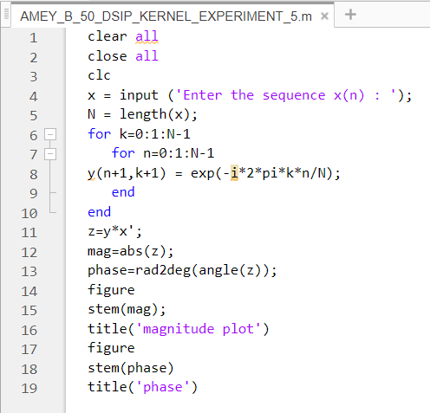

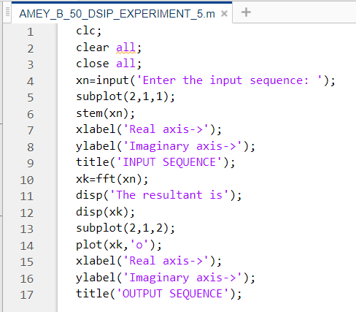

**B.2 Input and Output:**

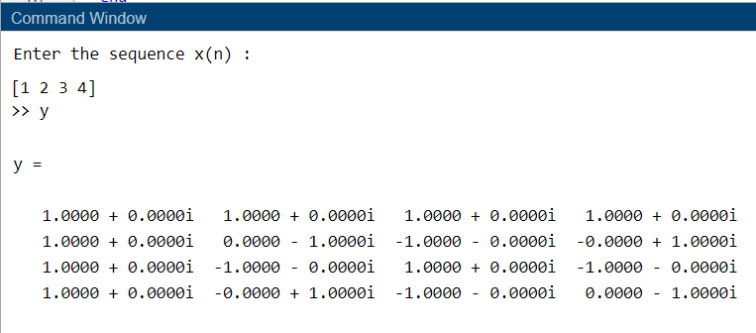

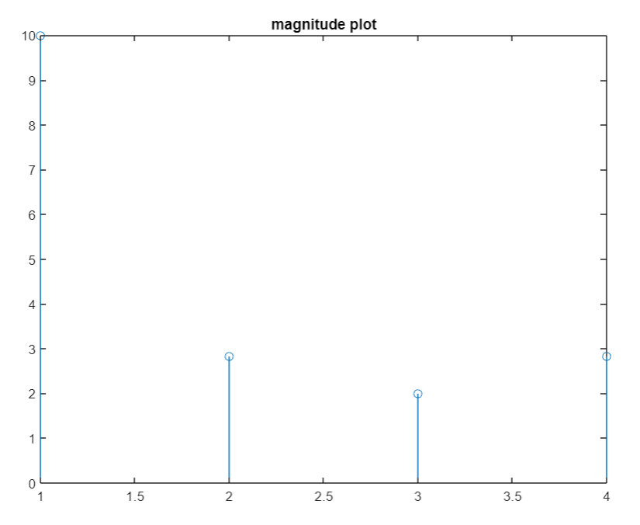

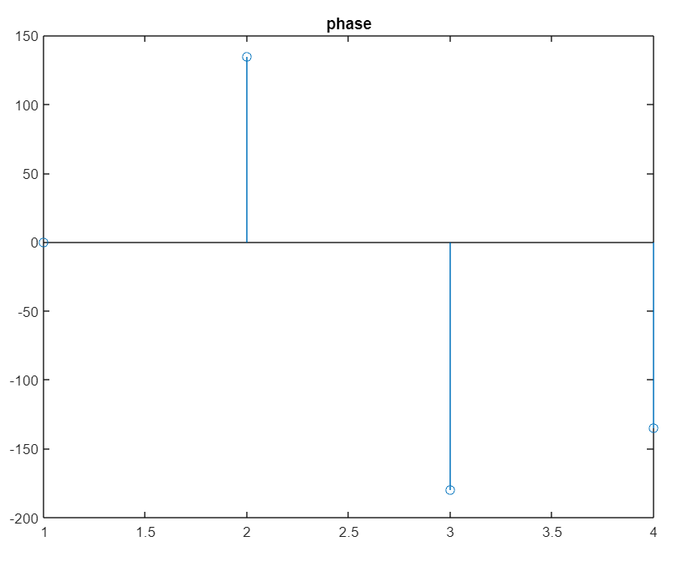

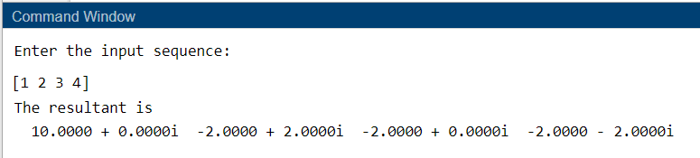

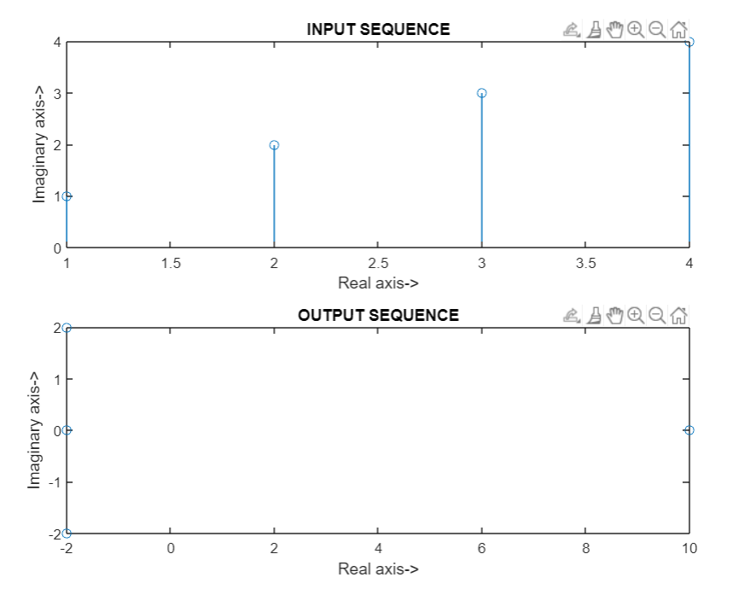

**B.3 Observations and learning:**

***(Students are expected to comment on the output obtained with clear observations and learning for each task/ subpart assigned)***

After successful completion of this experiment we are able to Able to develop Fast Fourier Transform flow-graph.

**B.4 Conclusion:**

***(Students must write the conclusion as per the attainment of individual outcome listed above and learning/observation noted in section B.3)***

Write a program to implement Radix – 2 DIT/FFT algorithm to find DFT/IDFT of given sequence x(n).

**B.5 Question of Curiosity:**

***(To be answered by student based on the practical performed and learning/observations)***

1. In 16 – point radix 2 DIT-FFT algorithms, how many numbers of real multiplications and real additions are required?

Ans:

**Concept:**

The N-point DFT is given as:



The number of complex additions and multiplications in direct DFT are N(N - 1) and $N^{2}$

For a large value of N, it will take a large time to compute the DFT.

So, we use a different technique called fast Fourier transform (FFT) which follows the "Cooley-Tukey" algorithm.

The number of complex additions (P) and multiplications (Q) will be:

P= N log2N

Q= $\frac{N}{2}$ log2N

**Calculation:**

Given that, N = 16

Number of complex additions P = 16 log 16 = 64

Number of complex multiplications Q = 16/2 log 16 = 32

1. The number of stages in the flowgraph is given by M = ---------

Ans: v = log 2 N

1. What is the main advantage of FFT?

Ans: The fast Fourier transform (FFT) is a computationally efficient method of generating a Fourier transform. The main advantage of an FFT is speed, which it gets by decreasing the number of calculations needed to analyze a waveform.